SALT FESTIVAL
EVENT SAFETY RISK ASSESSMENT
AND EVENT MANAGEMENT PLAN

Guidelines

For small to medium sized community events held within SALT Festival

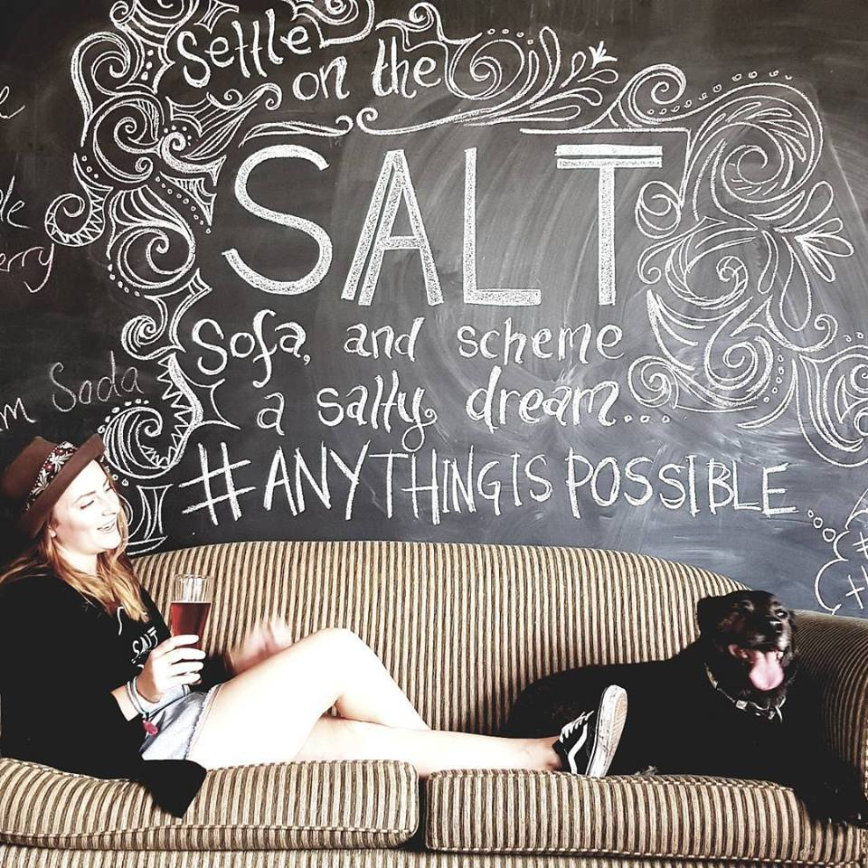

EVENT SAFETY AND PLANNING
As part of any good planning process hazards should be identified and risks assessed and controlled to minimise the potential for injury or harm. Events vary in size, nature and type, but all events require assessment, control and monitoring of risks.
SALT FESTIVAL requires that before an event is held on as part of the Festival including on Council or public land, relevant permits and licences are obtained and that a risk assessment and Event Management Plan (attached) is completed and forwarded to info@saltfestival.com.au .
Refer to the SafeWork SA website www.safework.sa.gov.au for guidance on how to manage work health and safety risks that should be undertaken before an event takes place (search Event Safety).
Please note that permits are required for fireworks and detailed procedures must be followed to ensure safety of crowds when using fireworks and Council must be informed prior to the event. For more details regarding fireworks please contact SafeWork SA on Telephone: 1300 365 255 or (08) 8303 0400.
CHECKLIST FOR PLANNING YOUR EVENT
Have you…
- Decided on the objectives and what kind of event you want to have?
- Found other people who will organise the event with you?
- Divided up the tasks that need to be accomplished?
- Setting a date for your event?
- Picking a venue?
- Setting a time?
Have you…
- Made a budget?
- Made a plan for obtaining funds?
- Secured your venue?
- Obtained a permit from Council to conduct the event?
- Obtained relevant licences/ permits relating to food/alcohol/ fireworks?
- Obtained relevant licences/ permits relating stalls/ events from Council?
- Investigated whether roads need to be closed and discussed with Council?
- Undertaken a risk assessment (see attached)?
- Considered risk/safety issues (see below)?
- Ensure that you have properly addressed your waste disposal with the Council?
- Created a plan for promoting your event?
- Set an agenda?
- Invited participants?
- Made sure your venue caters to people with disabilities?
- Taken care of all the details, like:
- Organised transportation, if necessary?
- Ordered the food and organised the meals?
- Organised lodging, if necessary?
- Confirmed the attendance of your participants and speakers?
- Created a map to your venue or given directions?
Are you prepared to…
- Be flexible in case anything unexpected happens?
- MOST IMPORTANT, is someone accountable for making sure each of these tasks is accomplished?

EVENT MANAGEMENT PLAN: (Issues to consider when planning your event)
The following are examples of issues to consider when identifying the hazards and risk associated with your event.
(NB: This form can be completed by writing your comments/details in the box provided under each section and a copy of the completed pages can be forwarded to SALT Festival as your Event Management Plan).
Fireworks: Obtain a licence through SafeWork SA and notify them of all fireworks displays at least five (5) weekdays (excluding public holidays) before the display. A pyrotechnician intending to hold a fireworks display must notify the local community by a letterbox drop or an advertisement in the local newspaper.
Comments:

Major incident/ safety plan: What could be the worst-case scenario? What provision needs to be made for the emergency services? What will be the procedure for summoning assistance? How will they get in and out of the site? Is there a provision for first aid/medical facilities? Who is responsible, who would do what, have discussions been held with SA Ambulance, SAPOL and CFS?
Comments:

Health and Safety issues: the organisers of the event should ensure that contractors employed to set up/take down stands, exhibits, marquees etc submit appropriate health and safety policies, risk assessments and method statements. Exhibitors and vendors, etc should submit similar details.
Comments:

Electrical power: Is there sufficient power? Ensure all electrical and lighting equipment is tagged and in test date. Are there any overhead power lines or other cables? If you need to have long cable runs, they may require extra protection for the public? If in doubt, then check with Council.
Comments:

Traffic Control: Do roads need to be closed? What about parking facilities and access for vehicles, not only on the day of the event but before and after? Is there a need for access by large vehicles? Are any parts of the site unsuitable for vehicular traffic because of soft or uneven ground? What traffic routes will be needed? What effect will the event have on traffic passing the site or on local parking?
Comments:

Provision of alcohol? If so, relevant liquor licence should be obtained.
Comments:

Food available? If so, check relevant health laws.
Comments:

Provision of facilities - toilets, washing facilities, water supplies, provision for disposal of waste water, rubbish bins.
Comments:

Waste management: waste collection during setting up, during and after the event. What types of receptacles are to be used? How and when will they be emptied and by whom? Advise Council who in your group is responsible to ensure the site is left clean and tidy.
Comments:

Special needs groups: Consider the types of attendees such as children, elderly persons and the disabled - are there particular arrangements that need to be made, e.g. for ramps?
Comments:

Attendees: How many people are expected to attend the event? What is the site capacity? What means of access and egress are available? What level of stewarding will be required, and who will carry out this role?
Comments:

Organisers: How will you communicate with organisers and how will they be distinguished? How will you communicate with the crowd, exhibitors etc? What direction/information signs are required?
Comments:

Fire safety: control over use of flammable liquids, LPG or other gases e.g. in catering or in other demonstrations. The use of generators should be strictly controlled - ensure adequate screening and protection, adequate arrangements for storage of fuel, etc. Adequate and appropriate fire extinguishers should be provided in accessible positions near to high risk areas.
Comments:

Security and cash handling arrangements: site perimeter security, entry/ticketing arrangements. Potential risk of theft of cash, valuables and equipment must be considered. The use of a professional security company may be required for larger events.
Comments:

Exhibitors, amusements, stalls and demonstrations: think about the interaction between adjacent stalls/exhibits/demonstrations and the problems that may result from having conflicting activities going on next to one another. Consider the positioning near to traffic routes, entrances/exits and toilet or refreshment facilities.
Comments:

Structures: are any temporary structures going to be erected? Are they to be erected by competent persons? Do they need permit from Council?
Comments:

Contingency plan: in place should there be adverse weather conditions.
Comments:

Please also refer to Council’s policies for further information which can be obtained from Council’s website www.portlincoln.sa.gov.au or from the Council office (Level One, Civic Centre, 60 Tasman Terrace, Port Lincoln, SA, 5606, Telephone 8621 2300):
Risk Management Policy 18.63.5 | Commercial Use of Footpath 20.63.1
Public Liability Insurance 15.63.1 | Use of Council Marquee 16.63.6
Liquor & Entertainment Venue Licences 3.63.6 | Community Advertising 2.63.6
Conditional Dry Zone Exemption 17.63.1

SALT FESTIVAL - Event Management Plan Risk Assessment
(To be filled in and submitted to SALT FESTIVAL at info@saltfestival.com.au )

Name of Event: | Exact location of event:
Date and time of event: | Expected number of attendees:
Event Manager - organiser name, address and telephone no: | Person/s completing Risk Assessment:

Task, Issue or Hazard | What could go wrong | Person affected, location | Risk Rating  (re risk matrix) | Risk Control Measures | By who and when | Notes and comments
EG: Crowds | Crushing | Any person at the event | Refer to “Risk Matrix” attached | Design layout of event to reduce concentration of people in any one place | Event Coordinator  Mr Jo Bloggs 1/1/xx | Volunteers to also assist with crowd segmentation

Task, Issue or Hazard | What could go wrong | Person affected, location | Risk Rating  (re risk matrix) | Risk Control Measures | By who and when | Notes and comments
Risk Matrix
Likelihood | Consequences
 | Insignificant |  | Minor | Moderate |  | Major |  |  | Catastrophic
Almost Certain | High |  | High | Extreme |  | Extreme |  |  | Extreme
Very Likely | Medium |  | High | High |  | Extreme |  |  | Extreme
Possible | Low |  | Medium | High |  | Extreme |  |  | Extreme
Unlikely | Low |  | Low | Medium |  | High |  |  | Extreme
Rare | Low |  | Low | Medium |  | High |  |  | High
Risk Matrix Legend
Low | Broadly acceptable risk
Moderate | Monitor & further review where practicable
High | Attention required
Extreme | Immediate action required

Impact | Medical Condition, Injury or Disability | Environmental | Social/Health & wellbeing of individual or community | Risk Likelihood
Insignificant | No medical attention is required  Any injury or illness is minimal  No loss of life | No immediate or long term harm to the environment | Incidental community issue with small scale impact | Almost Certain | Is expected to occur in most circumstances
Minor | Potential for health impacts and/or medical treatment  Medical attention may be required but no hospitalisation required  No loss of life | Immediate environmental nuisance or minor physical damage (e.g. non-toxic waste disposal)  No medium or long term impact  Impact at an individual level | Minor short term local issue  OR  incidental issue with wide scale impacts | Very Likely | Will probably occur in most circumstances
Moderate | Medical attention or ongoing medical treatment is required  No hospitalisation or long term effects  Potential for temporary disability  No loss of life | Discomfort caused to multiple members of the public  Impact on the environment for medium term (e.g. up to 3 years)  Some investigation & inspection required | Significant community incident | Possible | Might occur at some time
Major | A single fatality  Serious injury or illness leading to hospitalisation  Need for ongoing treatment and possibility of permanent disability  Multiple serious injuries | Immediate intervention required  Medium to long term impact on the environment (e.g. more than 3 years)  Contamination beyond localised site or point of origin  Significant loss or damage to infrastructure | Medium term issue with major community impact  OR  A significant impact with wide scale impacts | Unlikely | Could occur at some time
Catastrophic | Multiple fatalities or potential for multiple fatalities | Long term detrimental impact (e.g. more than 5 years) | Long term issue with major community impact | Rare | May occur only in exceptional circumstances

